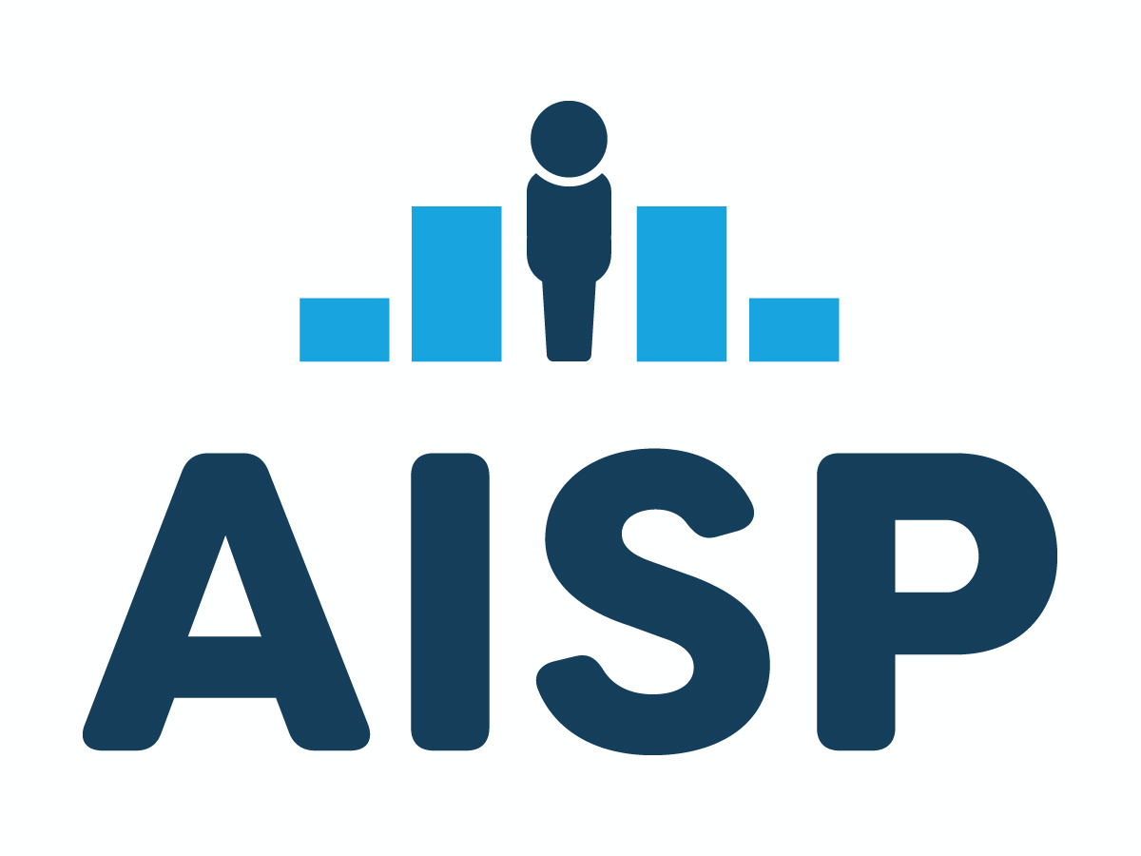
REQUEST FOR APPLICATIONS
AISP Learning Community
Building & Sustaining Cross-Agency Data Sharing
Issued: June 8, 2026

What | New cohort-based training initiative
Who | City, county, or regional Integrated Data Systems (IDS) or public sector data collaborations with a commitment to strong data governance and data use to promote health equity
Why | Cross-sector data sharing can transform information about individuals into actionable intelligence that can be used to understand needs, improve services, and build stronger, healthier, and more just communities. Yet use of cross-sector data can also produce inequitable resource allocation, access, and outcomes. To avoid this, we must develop strong data governance and clear legal frameworks to guide questions and practices throughout the data life cycle.
How | AISP’s Learning Community (AISP LC) will provide expert guidance and a peer cohort for sites to develop and implement the AISP IDS Quality Framework across governance, legal, technology, capacity, and impact. Coaching and facilitation will focus on shifts to policy and practice across the data life cycle.
When | The initiative will run from September 2026- September 2028 (24 months)  Applications due August 17, 2026  Optional applicant webinar: June 23rd at 2:00pm ET Register here  Three sites will be selected for participation by September 30th.
Funded Activities | Communities selected for participation will receive:  - Customized needs assessment, training and coaching from experienced practitioners  - Access to a rich community of peers and mentors working in the field of IDS  - Tuition, travel, lodging, and meals for two in-person convenings for site teams of up to four people
Criteria for Eligibility | Applications must include a local government agency as lead or co-lead and will be assessed for:  - Leadership buy-in across partners interested in sharing and using cross-sector data to support social policy planning and analysis  - Clear articulation of a cross-sector data integration use case related to social determinants of health and health equity  - Commitment to developing strong data governance and legal frameworks to support their work across the data life cycle  - Inclusion of key roles for data sharing, including a legal representative
AISP Contact | Kristen Egoville, krsm@upenn.edu
Table of Contents
Why Health Equity? 3
Why Shared Data Infrastructure + Strong Data Governance? 3
What is the AISP Learning Community? 3
What is AISP? 4
What can a Learning Community Site expect to gain? 5
Who should apply for the Learning Community? 5
How will AISP training services be awarded? 6
What are the expectations of selected sites? 7
About the Application Process 7
Application Components 7
RFA Schedule 7
How should I prepare and submit my application? 8
Who is the AISP point of contact? 8
Application Components 9
Part A: Contact Information 9
Part B: Application Narrative 10
Appendix A: Template for Partner Letters of Support 11
Appendix B: AISP Learning Community MOU 12

Why Health Equity?

“Health equity means that everyone has a fair and just opportunity to be as healthy as
possible. This requires removing obstacles to health such as poverty, discrimination, and their consequences, including powerlessness and lack of access to good jobs with fair pay, quality education and housing, safe environments, and health care.”
Braveman et. al., 2017, What is Health Equity?, Robert Wood Johnson Foundation

Public health data and data systems take the pulse of our society; they measure and indicate how well we sustain the life and vitality of our population. Data are the building blocks for how we describe the health of people and the communities where we live—stories that emerge from data help the nation understand and contextualize what drives or impedes health and how structural factors influence one’s ability to live a healthy life.

Yet in our current data ecosystem, data on health are often decontextualized from history and the experiences of individuals, communities, and places that impact health. Good health begins not in the doctor’s office but in the places where we live, learn, and work. To understand and evaluate root causes and improve health equity, we must reimagine how data on key determinants of health (such as housing, employment, and education) are collected, shared, accessed, and used.

Why Shared Data Infrastructure + Strong Data Governance?

Data sharing and integration is increasingly commonplace at every level of government as a tool
to support the interconnected needs of children, families, and communities more effectively and holistically. Integrating data across domains provides a comprehensive picture of risk and resilience and, therefore, also represents an opportunity for transformational data use that can drive program and policy changes towards health equity. At the same time, many of the institutions engaged in the important work of data integration have few supports in developing participatory data governance and strong legal frameworks that provide the foundation for data sharing and integration that is legal and ethical, prioritizing data access and use that improves the lives of residents.

What is the AISP Learning Community?

Since 2008, AISP has supported local and state level jurisdictions through the process of developing robust data governance for shared data infrastructure. Our mission, track record, and activities are centered on building sustainable integrated data systems. We operate a network of 50+ sites across the U.S. and provide technical assistance to jurisdictions at various stages of integrating and using cross-program administrative data. We have offered nearly two decades of IDS-focused convenings and learning communities and have supported 5 previous learning communities from 2017-today, supporting 31 sites in their journey from development to implementation.

Engagement in the AISP LC will provide participating sites with the opportunity to work with a team of partners locally and with a cohort of peers and experienced practitioners from across the U.S. While most training and engagement will take place virtually, participants will also meet with their peers, mentors, and the AISP team in person for two 2.0-day meetings in Baltimore, MD during the 24-month TA period. AISP will cover the costs of travel, meals, and lodging for four participants from each site for these meetings. AISP will work with sites to ensure that successes, challenges, and lessons learned are well documented both internally, to support sustainability of practice, and externally, to support broader field-building efforts.

AISP has received support from the Annie E. Casey Foundation and the Robert Wood Johnson Foundation to engage sites over a 24-month period from September 2026 to September 2028. The AISP Learning Community builds upon previous data capacity-building funded by the Annie E. Casey Foundation and the Robert Wood Johnson Foundation and Recommendations from the National Commission to Transform Public Health Data Systems.

The Robert Wood Johnson Foundation (RWJF) is committed to improving health and health equity in the United States. In partnership with others, they are working to develop a Culture of Health rooted in equity that provides every individual with a fair and just opportunity to thrive, no matter who they are, where they live, or how much money they have. For more information, visit www.rwjf.org.

The Annie E. Casey Foundation is devoted to developing a brighter future for millions of children and young people with respect to their educational, economic, social and health outcomes. Casey advances research and solutions to overcome the barriers to success, help communities demonstrate what works and influence decision makers to invest in strategies based on solid evidence. Learn more at aecf.org.

What is AISP?

About Us
Actionable Intelligence for Social Policy (AISP) is an initiative based at the University of Pennsylvania’s School of Social Policy and Practice. Since 2008, we have helped state and local government agencies and partners collaborate and responsibly use data to improve lives. We currently represent a Network of 50 cities, counties, and states across the US who routinely integrate data at the person level to support social policy planning and analysis. These jurisdictions, comprising over 53% of the US population, have been collaborating for almost two decades to develop national standards, share best practices, and use data ethically and equitably. Whether they call themselves integrated data systems (IDS), data hubs, data collaboratives, or data intermediaries, these efforts are working towards the same goal: routine and responsible use of cross-sector data for good.

What We Do
- Convene and advocate on behalf of communities that are sharing and using cross-sector data for good
- Connect to innovations, best practices, and research and funding opportunities that support ethical data sharing
- Consult with data sharing collaborations to build the human and technical capacity to share data and improve lives

Why We Do It
When communities bring together cross-sector data safely and responsibly, policymakers and practitioners are better equipped to:
- Understand the complex needs of individuals and families
- Allocate resources where they’re needed most to improve services
- Measure long-term and multi-generational impacts of policies and programs
- Engage in transparent, shared decision-making about how data should (and should not) be used

To learn more about our approach, explore AISP’s Introduction to Data Sharing & Integration (2025) and AISP’s Quality Framework for Integrated Data Systems (2021).

What can a Learning Community site expect to gain?

There are a host of benefits that sites will gain as members of the AISP Learning Community. Some of these benefits include:

- A customized needs assessments of each state or local data landscape and team readiness, facilitated through a virtual or in-person site visit conducted between selection and the first in-person convening
- Advice and facilitation from experienced practitioners to support IDS development, implementation, and refinement across the AISP Quality Framework: governance, legal, technical, capacity, and impact
- Guided support for the development of a legal analysis of relevant federal privacy laws pertaining to data sharing and a templated version for legal research at the state and local level
- Access to templates, resources and guidance to create and refine the necessary legal infrastructure to enable data sharing
- Access to mentor sites and a peer community where cross-agency teams can share and learn from each other
- Practice techniques to right-size data holdings that support a more holistic view of individuals, families, and communities, including data from community-based organizations
- Increased awareness and understanding of how to center ethical use of data by increasing benefit, mitigating risk, and incorporating community voice in decision making
- Increased capacity to shift policy and practice and demonstrate impact with a customized roadmap for sustainability of the effort

Who should apply for the Learning Community?

We expect this to be a diverse pool of applicants and are interested in supporting IDS and other public sector data collaborations with a commitment to strong data governance and legal frameworks at the local (city, county, tribal) or regional level. The lead partner may be a government agency, university, or non-profit. Applicants must involve a government agency as a key member of the team. Applicants may be located anywhere in the United States, and must meet the following requirements:

- Demonstrated leadership commitment to build capacity to integrate and use cross-sector data on social determinants of health (at the individual, person level) to support social policy planning and analysis. Committed data partners may include a wide range of human services, including vital records (birth, death records); health (APCD, Medicaid, public health, EMS, etc.); child & family welfare (juvenile justice placement, adult protection, etc.); early childhood; education (K-12, post-secondary); legal system and law enforcement (courts, corrections, probation); economic security (TANF, UI, etc.); and homelessness/housing (HMIS, PHA, etc.).

Documentation of commitment to build data capacity or current capacity may include letters of support, cooperation agreements, (draft or outdated) legal agreements, a technical approach to facilitate integration at the person level, governance structures, and initial use cases. This leadership commitment will also be assessed based on an articulation of a cross-sector use case for data sharing and a willingness to designate key team roles to achieve stated goals.

- Demonstrated commitment to center strong data governance in data integration and across the data life cycle. We are looking for participants with a growth mindset who are committed to reflecting, learning, and changing practices, both personally and professionally. We believe this training will be most effective for agencies with a leadership commitment to health equity and participatory processes. We do not expect applicants to have figured out how to operationalize this commitment (this is one goal of the Learning Community), but we are looking for evidence that your team has begun the process of awareness-building and is ready for explicit conversations and culture change.

Members of the AISP Network are welcome to apply and will be evaluated by the same standards as all applicants.

How will AISP training services be awarded?

All eligible applications will be reviewed by a multi-member panel at AISP for responsiveness to the questions listed in Part B of the application (see page 9). Each eligible application will be scored on the elements listed below. *

60% | Demonstrated commitment to build capacity (or existing capacity) to integrate and use cross-sector data on social determinants of health to support social policy planning and analysis: Successful applicants will describe their current and aspirational (yet realistic) use of administrative data and desired data capacity. This may include demonstrated support for cross-agency use cases; staffing plans; potential data sharing partnerships and initial discussions among agencies; current or planned data governance structures and data access and use processes; and/or a description of current or planned technical approach for integrating data. Both narrative responses to Part B and the Part C self-assessment will be used to evaluate this element.
30% | Demonstrated commitment to center strong data governance and legal frameworks in their work across the data life cycle: AISP is seeking applicants with a commitment to building strong data governance and legal frameworks. This most often is indicated by having the support of executive leadership and legal counsel. Narrative responses will be used to evaluate this element, and finalists may be asked to participate in interviews.
10% | Commitment to participatory processes and community participation: AISP is seeking applicants with demonstrated relationships and connections to the community in which the project activities will take place. Successful applicants will describe both their current and future plans to incorporate community participation in data governance and inquiry activities.

*Not all criteria must be met for an applicant to be selected. AISP may follow up with applicants to obtain more information to inform the selection process.

What are the expectations of selected sites?

All applicants will be expected to do the following:

- Actively participate in the customized needs assessment that will be conducted for each site;
- Ensure that at least four representatives will participate in each of the two-day in-person training convenings;
- Dedicate a minimum of 15 hours of staff time per month to the LC;
- Maintain regular correspondence with each other, AISP, and other sites;
- Actively participate in virtual AISP activities;
- Sign an MOU with AISP to govern partnership over the 24-month engagement (see Appendix B)

About the Application Process

Application Components

All application components are included with this Request for Applications (RFA) for the LC. AISP will host an informational webinar on this RFA on June 23rd at 2:00pm ET. Register here. This will include opportunities for participant questions on the elements of this application, our evaluation process, and/or the services offered. Applicants may also submit questions about the RFA to AISP Senior Coordinator, Kristen Egoville, krsm@upenn.edu).

Application components:
- Application Part A (contact information and key organizations, required)
- Application Part B (proposal narrative and self-assessment, required)
- Letters of Support from key data partners, community organizations, executive leadership (Agency Leaders, Mayor’s office, County Manager’s office), etc. (see template in Appendix A)
- Finalist interviews (to be scheduled by AISP in August)

RFA Schedule

June 8, 2026: AISP publishes RFA.
June 25, 2026 2:00 ET: AISP hosts an informational RFA webinar with opportunities for participant questions. A recording will be posted within one week of the webinar date. Attendance is optional. Register here.
August 12, 2026: Last day to submit questions to AISP (Kristen Egoville, krsm@upenn.edu).
August 17, 2026: Applications are due to AISP by 5pm Eastern.
August to September 2026: AISP reviews submitted RFA applications and makes follow-up calls/contact with applicants to gain additional information as needed.
September 4, 2026: Finalists notified via email for interviews.
September 7-September 18, 2026: Virtual interviews conducted for finalists.
By September 30, 2026: Selected finalists are notified via e-mail.
September - October 2026: MOU between AISP and each selected site is developed and finalized.
October 31, 2026: LC sites announced in AISP October Newsletter.
October 2026: Learning Community activities begin.
March 2027: First cohort convening anticipated.

How should I prepare and submit my application?

Please email one copy of your narrative application in PDF format to AISP Senior Coordinator, Kristen Egoville (krsm@upenn.edu). All applications should be no longer than 15 pages (not including additional materials, such as letters of support). All application pages should be numbered, font should be 12-point Times New Roman, text should have one-inch margins all around, and all relevant questions should be answered. Please combine all application materials into a single PDF. The online self-assessment can be accessed here and will be submitted automatically upon completion.

Who is the AISP point of contact?

Questions about this RFA and completed applications should be sent to AISP Senior Coordinator, Kristen Egoville (krsm@upenn.edu).

Application Components

Part A: Contact Information

Primary applicant:

Agency or organization name:
Location (state, county, city):
Agency/organization type:

Applicant point of contact:

Name:
Title:
Phone number:
E-mail:
Address:

Please list current and proposed data integration partners here. Include agency name, agency type, and whether a letter of support is provided. Common partners include state/county/city agencies and community-based organizations that support health, human services, child and family welfare, early childhood, education, housing and homelessness, economic security, workforce, legal system and law enforcement, etc.

Name of agency |  | Type of agency  (e.g. government, non-profit) | Letter of support? (Y/N)

Part B: Application Narrative

Please respond to the prompts below to provide information describing your organization, the data integration effort, your partners and relevant activities to date, and the challenges you would expect this Learning Community to address. Limit your response to these questions to no more than 15 pages (not including letters of support or supplemental materials).

- Goals and Objectives: Briefly describe your preliminary goals and objectives for participating in the LC. This section should include both goals for process improvement and a clear articulation of the primary use case(s) for sharing and integrating data. (Thought of another way: what are 2-3 key issues or problems that you hope to address?)
- Data Integration Effort and Partners: Briefly describe the purpose of your data integration effort more broadly. As relevant, include the history of development, mission, policy priorities, funding, and partners involved. Include a short description of each partner agency and their main role in the effort. (Note: Applicants are strongly encouraged to demonstrate engagement from partner agencies through letters of support. See Appendix A for template.)
- Demonstrated Cross-Sector Data Capacity:
  - Complete self-assessment tool here.
  - Please note that this tool was not designed for this RFA, but rather as a formative assessment for sites interested in building data integration capacity.
  - Be sure to include the name of the individual submitting this RFA under “Your Information.” so that we can accurately match each self-assessment to it’s application.
  - From your past or current work, briefly describe a successful data integration project.
  - Briefly describe an unsuccessful data integration project and a lesson you learned.

- Community Participation: Describe the ways that your data integration effort and key partners seek and respond to community feedback, particularly around data access and use.
- Staffing: List the primary point of contact and three additional staff from lead and partner agencies who will participate in the LC. Applicants must identify a designated legal representative who will participate as a core member of the team throughout the LC. This individual does not need to have subject matter expertise in data sharing but should be sufficiently engaged to support decision-making related to legal and compliance considerations. Explain the rationale for the individuals selected and how their experience and training will support this work.

Name, Title, and Role of Staff |  | Agency

Note: Staff listed above should:
  - have accommodations that will allow travel for two 2.0-day sessions over a 24-month period, and
  - be able to dedicate a minimum of 15 hours per month to this training effort.

Appendix A: Template for Partner Letters of Support

AISP Learning Community

Name of applicant:

Name of partnering agency supporting the application:

Partner representative (name, title, and email):

Please describe the nature of your partnership:

We understand the nature of this work and are excited to support our partner in their application for the AISP Learning Community.

Signature: __________________________________

Appendix B: AISP Learning Community MOU
Please note that this MOU is included as an example of a partnership agreement that will guide participation. You do not need to fill this out as part of your RFA response.

Memorandum of Understanding

between

Actionable Intelligence for Social Policy (AISP)

and

(Participating Organization or their Designated Representative)

This Memorandum of Understanding (MOU) sets forth the terms and understanding between Actionable Intelligence for Social Policy (“AISP”) and the (participating organization) which is participating in the AISP Learning Community, collectively (the “Parties”).

Organization name: Actionable Intelligence for Social Policy
Partner representative: Della Jenkins
Position: Executive Director
Address: 3701 Locust Walk, C19, Philadelphia PA 19104
Telephone: (215) 746-3245
E-mail: adeliaj@upenn.edu

Primary Agency/ Organization:
Primary point of contact:
Position:
Address:
Telephone:
Fax:
E-mail:

Purpose
The purpose of this MOU is to establish a shared understanding among the above-mentioned parties concerning their respective roles and responsibilities for implementation of the AISP Learning Community Site.

It is important that all partners to the MOU agree upon their respective roles and have a common understanding as to the scope and purpose of the program.

Duties of Parties
In this section, the responsibilities and agreements of each party is described separately.
For Actionable Intelligence for Social Policy, the responsibilities and activities include:
- Provide coaching, training, and curriculum materials;
- Conduct two, two 2.0-day, in-person training convenings over the course of a 24-month period;
- Cover the costs of travel, meals, and lodging for four participants from each site in these convenings;
- Provide training materials and host online file sharing that will house all Learning Community resources;
- Write up lessons learned and recommendations specific to the Site and to the cohort overall and provide the Site a chance to review evaluation findings and public communications (case studies, etc.) before they are shared.

For the participating organization, the following apply:
- Ensure that at least four representatives (including at least one legal representative) will participate in each of the two 2.0 day, in-person training convenings;
- Dedicate a minimum of 15 hours of staff time per month to the training program;
- Complete pre-work assignments for the program;
- Maintain regular correspondence with the AISP TTA team and other sites;
- Actively participate in AISP Learning Community activities;
- Participate in formative and summative evaluation of the AISP Learning Community and TTA;

Duration
The MOU is for a period of twenty-four months covering the duration of the AISP Learning Community, from September 2026 to September 2028.

Procedures for Modification and Termination
- The MOU may be modified, revised, extended, or renewed by mutual written consent of both parties, by the issuance of a written amendment, signed and dated by both parties.
- Either party of the MOU may terminate their participation in this MOU by giving ten (10) days, written notice of intent to terminate to the other partner.

Signatures
All partners in this MOU sign to confirm their acceptance of its terms by their signature.

________________________ ________________________
(Della Jenkins, AISP) (Partner signature)
Della Jenkins Partner Printed Name
Executive Director
Actionable Intelligence for Social Policy
University of Pennsylvania Organization

Date: Date:

